**Visualization Challenge for BUAD 352**

**The Challenge:** Recreate the visualization below using Excel.

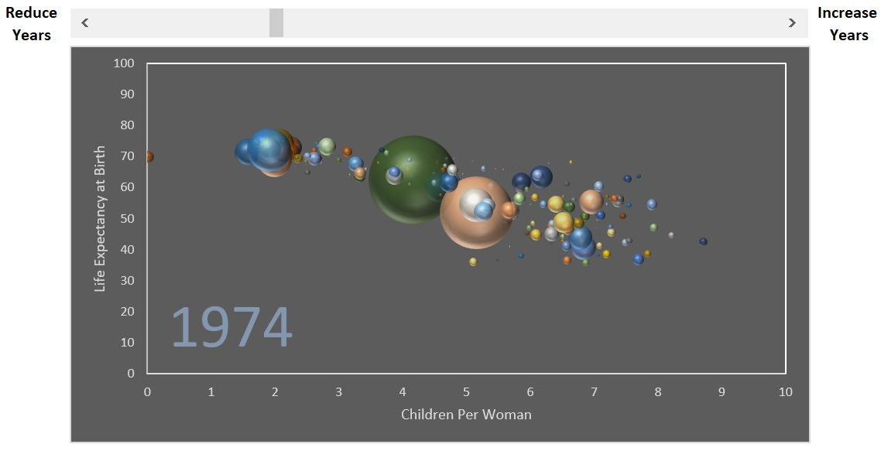

**Rules:**

* Life expectancy should be on the y-axis and children per woman should be on the x-axis.
* The third dimension, population, should be represented by the size of each circle (sphere).
* The y-axis must range from 0-100 (by 10’s) and the x-axis must range between 0-10 (by 1’s).
* Each axis must include a title describing the variable it is measuring.
* You must include the year in the visualization. This year should be linked to a scroll bar.
* You must include a scroll bar. When you click the right arrow of the scroll bar, the year in the graph must increase by one. When you click the left arrow of the scroll bar, the year in the graph must decrease by one.
* When you either hit the right or left button of the scroll bar your entire visualization should update to the specified year.
* You must use the Match and Offset functions to complete the challenge. Feel free to name your ranges.
* Make at least one improvement on the chart (this could be formatting, headers, text boxes, or any other). Your choice.
* Once you are done submit your work to blackboard as an excel file “VizChallengeLastFirst.xlsx”
* Note: You can remove any country that does not have a complete set of observations, or a year that is not in all three tables.